Thesis title pages

Acknowledgments
The acknowledgment page shall be included in the thesis manuscript. In this section, author could express his/her sincere gratitude to his/her family for support and so on. Author could also include his/her special thank to Professors, Thesis Advisor, Lab Assistant, and other personnels who have been providing help during the research and the preparation of thesis. The order of gratitude shall be classified based on the degree of supporting. It means that person who has been of great help should appeared first.

Abstract
Each thesis shall contain a concise and factual abstract of maximum 1 page. The abstract should contain the purpose of the research, the materials and methods, the principal results and major conclusions. An abstract must be written in 3 languages (Khmer, French and English in order) except Associate Degree Abstract must be written only in Khmer. In the case of Abstract in Khmer, all technical terms must be remained in original language except common and well-known technical terms could be used in Khmer. Moreover, this abstract should be presented separately from the thesis manuscript, so it must be able to stand alone. Therefore, references should be avoided, but if essential, then cite the author(s) and year(s). Moreover, non-standard or uncommon abbreviations should be avoided, but if essential they must be defined at their first mention in the abstract itself.

Abbreviations and Symbols
All abbreviations and symbols that are not standard and well known in the field of enginnering should be defined in the abbreviations and symbols page. In the case that any abbreviations that are unavoidable in the abstract, they must be defined at their first mention in the abstract. Furthermore, it is necessary to maintain the consistency of abbreviations and symbols throughout the thesis manuscript.

Table of Contents
Acknowledgments i
Abstract ii
Abbreviations and Symbols iii
List of Figures v
List of Tables vi
1. Introduction 1
1.1. Header 2 1
1.1.1. Header 3 1
2. Literature Review 2
2.1. Header 2 2
2.1.1. Header 3 2
3. Methodology or Materials and Methods 3
3.1. Header 2 3
3.1.1. Header 3 3
4. Results and Discussion 4
4.1. Header 2 4
4.1.1. Header 3 4
4.2. Sub-title 2 4
4.2.1. Sub-title 3 4
4.2.2. Sub-title 3 4
5. Conclusions (and Recommendations) 5
5.1. Header 2 5
5.1.1. Header 3 5
References 6
Appendices 8

List of Figures

Figure 1.1. Sample Picture 1 5
Figure 1.2. Sample Picture 2 5

List of Tables
Table 2.1. Sample Table 1 5
Table 2.2. Sample Table 2 5

Introduction

Header 2

Header 3

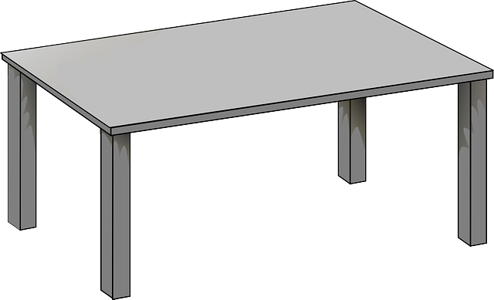
Figure 1.1. Sample Picture 1
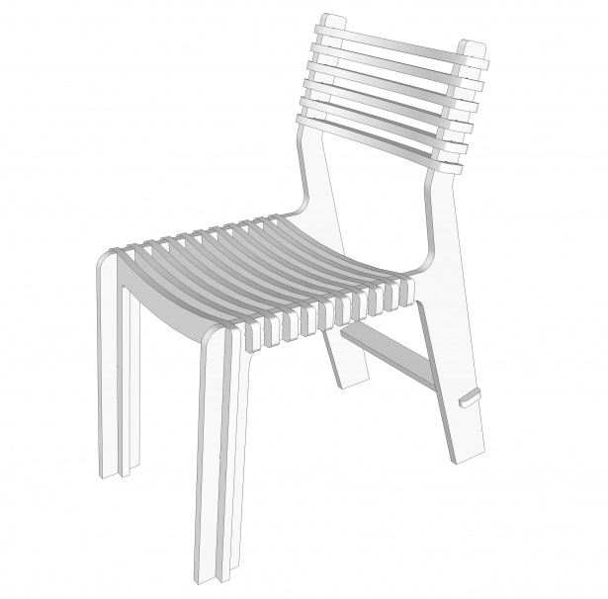

Figure 1.2. Sample Picture 2

Literature Review

Header 2

Header 3
Table 2.1. Sample Table 1

Table 2.2. Sample Table 2

Methodology or Materials and Methods

Header 2

Header 3

Results and Discussion

Header 2

Header 3

Sub-title 2

Sub-title 3

Sub-title 3

Conclusions (and Recommendations)

Header 2

Header 3

References
It is a must to ensure that each reference cited in the thesis manuscript is also presented in the reference list, and vice versa. It is recommended that the unpublished results and personal communications should not be used for citation. References list should be arranged alphabetically. In the case that more than one reference from the same author(s) in the same year, it must be identified by the letters “a”, “b”, “c”, etc; these letters should be placed after the year of publication.
For example: Author “Mongkul” has published two journals in 2013 and we would like to reference these two journals; thus, the citation will be “Based on the recent study (Mongkul, 2013a, 2013b),…”.
Reference list should be prepared based on the type of document, for instance:
- Reference to a journal publication:
Hul, S., Ng, D.K.S, Tan, R.R., Chiang, C.L., Foo, D.C.Y., 2007. Crisp and Fuzzy Optimisation Approaches for Water Network Retrofit. Chemical Product and Process Modeling. 2, 1934– 2659.
- Reference to a book:
Nester, E.W., Anderson, D.G., Roberts, C.E., Pearsall, N.N., Nester, M.T., 2004. Microbiology-A human perspective. 4th ed. McGraw-Hill, New York.
- Reference to a chapter in an edited book:
Mettam, G.R., Adams, L.B., 2009. How to prepare an electronic version of your article, in: Jones, B.S., Smith, R.Z. (Eds.), 2009. Introduction to the Electronic Age. E-Publishing Inc., New York, 281–304.
- Reference to the internet
A clear source and official website can be used as reference. However, a clear authors and date of the website or the agency creating the website should be stated. For example:
Food and Agriculture Organization of the United Nations 2011. Cambodia and FAO achievements and success stories, http://www.fao.org/fileadmin/templates/
rap/files/epublications/CambodiaedocFINAL.pdf (Consulted on March 01, 2013).
References in the list should be placed alphabetically, for example:
Arun, A.B., Chen, W.M., Lai, W.A., Chou, J.H., Shen, F.T., Rekha, P.D., Young, C.C., 2009. Lutaonella thermophilagen. nov., sp. nov., a moderately thermophilic member of the family Flavobacteriaceae isolated from a coastal hot spring. International Journal of Systematic and Evolutionary Microbiology. 59, 2069–2073.
Boone, D.R., Castenholz, R.W., Garrity, G.M., 2001. Bergey’s manual of systematic bacteriology. 2nd ed. Springer, New York.
Bosshard, P.P., Zbinden, R., Altwegg, M., 2002. Turicibacter sanguinis gen. nov., sp. nov., a novel anaerobic, Gram-positive bacterium. International Journal of Systematic and Evolutionary Microbiology. 52, 1263–1266.

Appendices
Appendices are supplemental to a thesis in nature; the same formatting, pagination, margins, and illustration requirements apply to appendices. Formulas, equations, and additional information should be included in this section.

